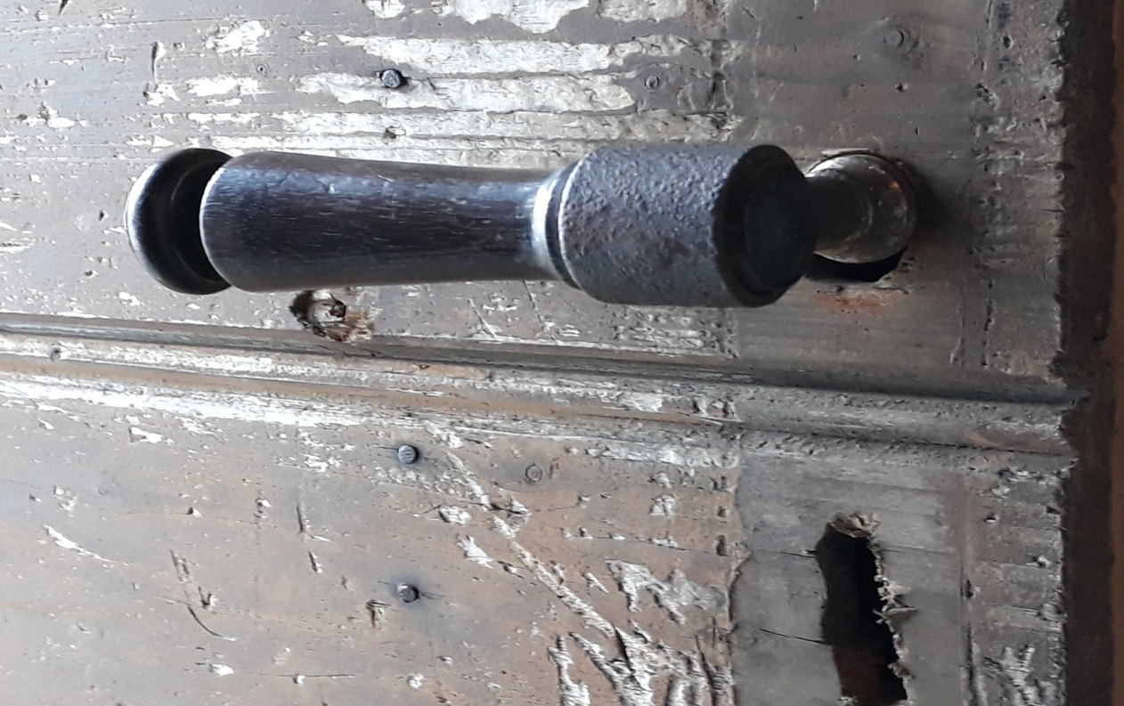

International architecture student workshop –
Wooden architecture heritage of Aizpute
9 – 12 May, 2019
Workshop about values and development of the wooden architecture heritage of Aizpute town –
cityscape, street landscape, materials, colour schemes, signs and details.

Participants:
RISEBA School of Architecture
Vilnius Art Academy, Klaipeda faculty
Latvian University of Agriculture (landscape architects)
Riga Technical University

Invited experts, tutors and guest lecturers:

Architect Malin Belfrage (White Architects, Sweden)
Dr.arch. Jana Jākobsone (City architect of Kuldīga)
Dr.arch. Jānis Lejnieks (RISEBA, chief editor of magazine “Latvijas Architektūra”)
Mg.ing. Jānis Kreicburgs (Skonto būve, RISEBA)
Mg.art., artist Martinas Lapas (VAA, Klaipeda faculty)
Dr.arch., prof. Aija Ziemeļniece (LUA)
Mg.arch. Egons Bērziņš (RTU)
Dr.arch.h.c. Jānis Dripe (RISEBA)
Programme:

Day one – 09/05
Around 17.00 – arrival to Aizpute, Idea House, Katoļu str. 5, www.idejumaja.lv, tutors – Mētras māja, Pasta str. 1A (+371 29545975).
18.00 – meet and greet activities, information about workshop content and programme, health and safety regulations. Venue: Idea House.
19.00 – official opening of workshop, reception hosted by Nordic Council of Ministers’ Office in Latvia in cooperaton with Aizpute District Council, Residency and workshop centre SERDE and RISEBA School of Architecture. Venue: centre SERDE, 9 Atmodas str.
Day two – 10/05
9.00–9.30 / breakfast time
10.00–13.00 / study tour to Kuldīga and meeting with the City Architect Jana Jākobsone (meeting point: TBA)
13.00–14.00 / lunch
from 14.00 – study of the site and work on the ideas for the workshop task (Idea House)
18.30 – dinner, evening activities (wine tasting)
Day three – 11/05
9.00–10.00 / breakfast time
10.00–13.00 / work on the concepts (Idea House)
13.00–14.00 / lunch time
14.00–17.30 / work on the concepts (Idea House)
18.30 – dinner and evening activities
Day four – 12/05
9.00–10.00 / breakfast time
From 10.00 – work on the presentations (Idea House)
11.00 – presentation of the concepts to the leadership and representatives of local authority of Aizpute. Moderator – Dr. arch. Jānis Lejnieks. Venue: club Kurzeme.
Final remarks and conclusions.

Organizers:
RISEBA Faculty of Architecture and Design, Jānis Dripe, + 371 28625222, janis.dripe@riseba.lv, www.architecture.riseba.lv
Aizpute District Council, Iveta Kļevcova – Aizpute Development division, project manager, + 371 29983141, iveta@aizpute.lv
Supported by Nordic Council of Ministers’ Office in Latvia, www.norden.lv
More information about Aizpute – www.visitaizpute.lv, www.serde.lv

